**Database Relational Model**

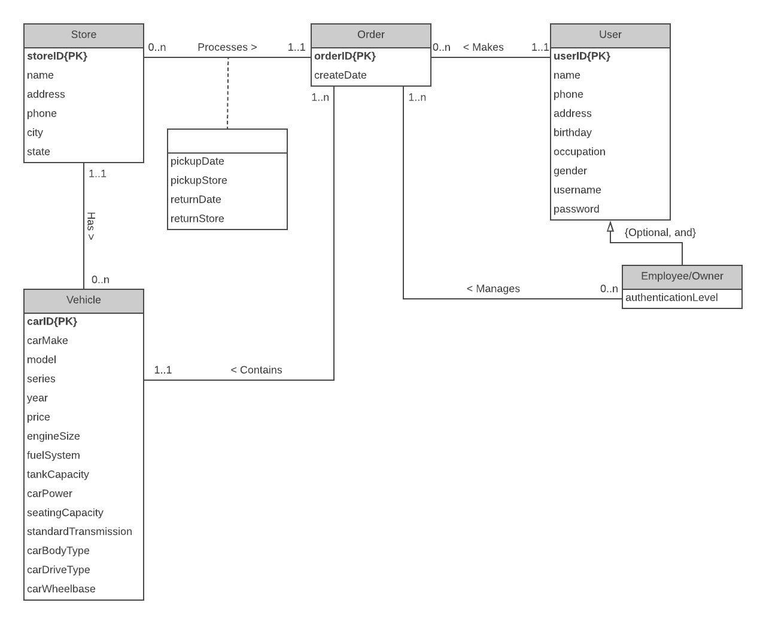

**Model Solution**

**User** (userID, name, phone, address, birthday, occupation, gender, username, password, autenticationLevel)

**Order** (orderID, userID, carID, createDate, pickupDate, pickupStore, returnDate, returnStore)

**Store** (storeID, name, address, phone, city, state)

**Vehicle** (carID, storeID, carMake, model, series, year, price, engineSize, fuelSystem, tankCapacity, carPower, seatingCapacity, standardTransmission, carBodyType, carDriveType, carWheelBase)

**Foreign Keys**

* Order (pickupStore) is dependent on Store (storeID)
* Order (returnStore) is dependent on Store (storeID)
* Vehicle (storeID) is dependent on Store (storeID)
* Order (userID) is dependent on User (userID)
* Order (carID) is dependent on Vehicle (carID)